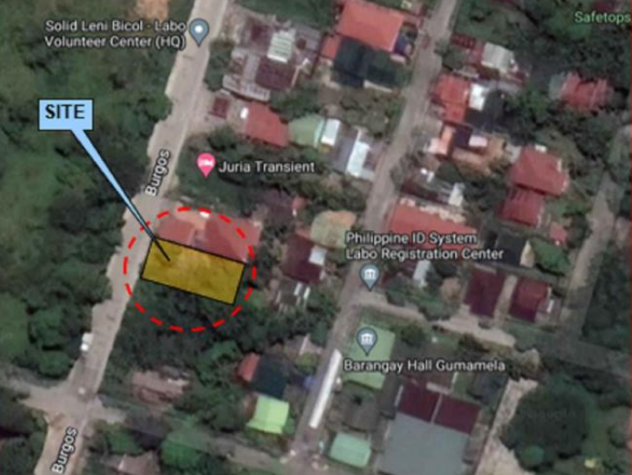

**Property II – Lot No. 2**

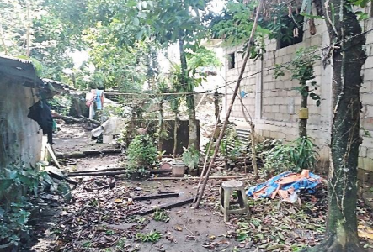

Asset Name : **Peninsula Development Bank**

TCT Nos. : T-58895

Area : 300 square meters

Location : Brgy. Gumamela, Labo, Camarines Norte