PROPERTY I
LOT NO. 6

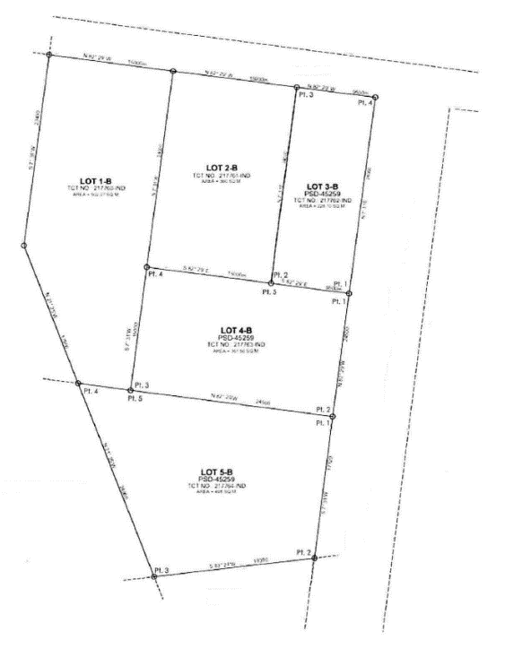
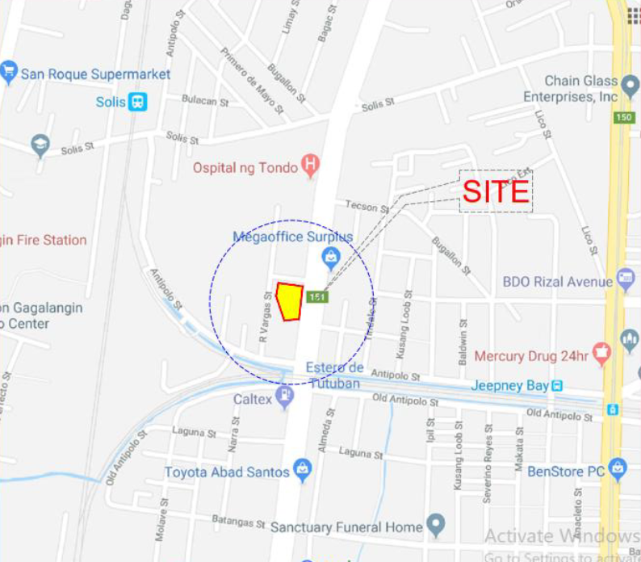

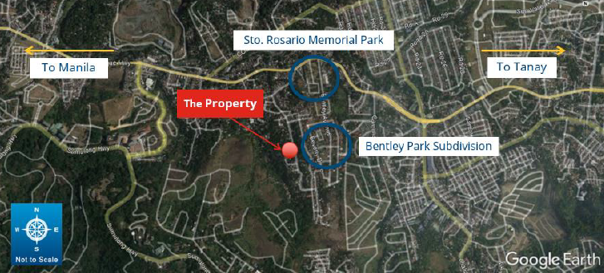

Name : Emmanuel Community Hospital, Inc. (ECHI)
TCT No. : 217760, 217761, 217762, 217763, 217764 (including building)
Area : 1955.67 square meters
Location : Jose Abad Santos Ave., Tondo, Manila

