PROPERTY I
LOT NO. 3

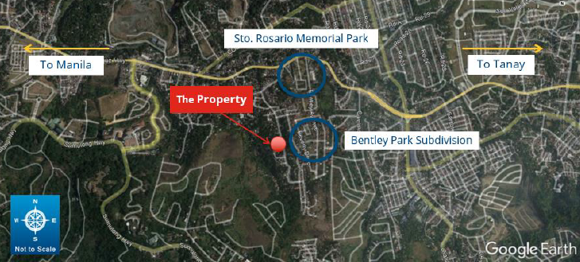

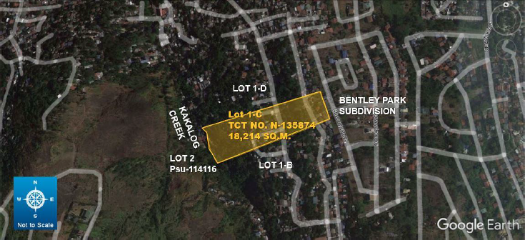

Name : Central Bank - Board of Liquidators (CB-BOL)
TCT No. : N-135874
Area : 18,214 square meters
Location : Barangay Sta. Cruz., Antipolo City

