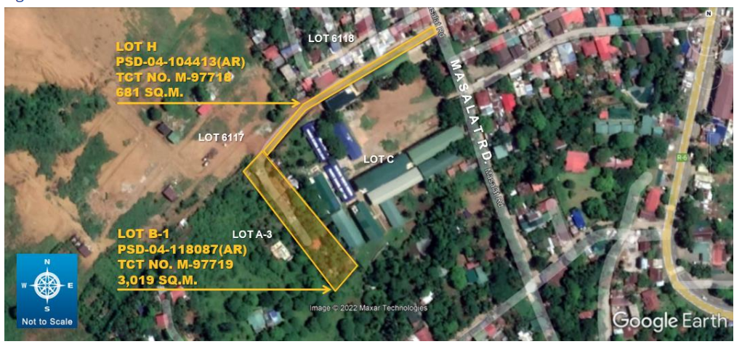
Property I – Lot No. 1
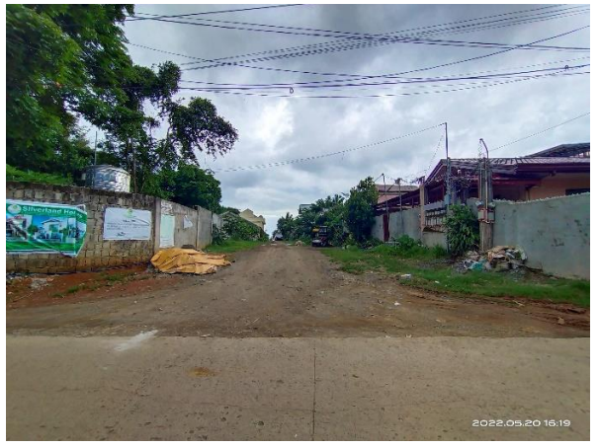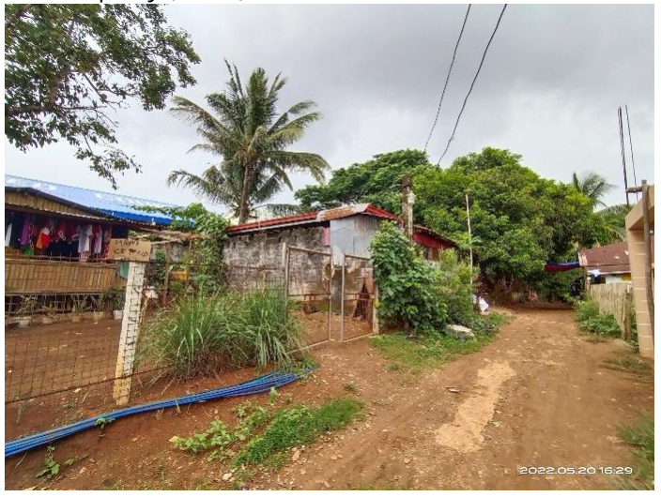

Asset Name : Selectra Electronics, Corp.
TCT Nos. : M-97718 and M-97719
Area : 3,700 square meters
Location : Brgy. Sampaloc, Tanay, Rizal

